This document summarizes the popup development for the bulk resource assignment in SPM, which is the replacement for the bulk assignment with drag and drop.

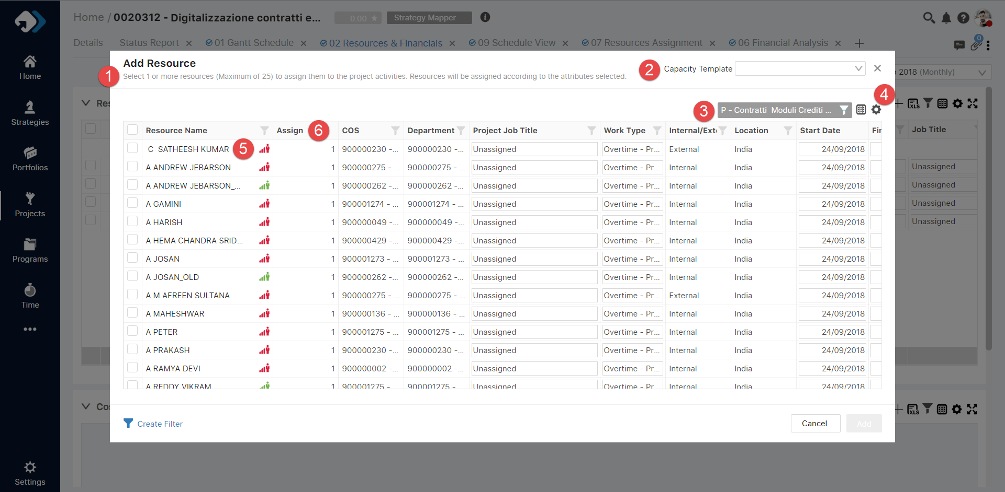

1. User can assign maximum of 25 resources by selection; hence head selection will work in case we have more then 25 resources on the grid.
2. We can filter out the list of resources based on the capacity template they are associated with; the filtering is done on client side.
3. We can select the activity on which we need to assign the resource.
4. We can further filter out the resources based on other fields such as department, skill, project etc. [See below]
5. Resource name is provided with the icon to mark the load, which opens up a chart for that resource.
6. Assign column is used to define number of assignments to be made for a particular resource, this works for generic resources only. In case of named resource this field will be read-only.

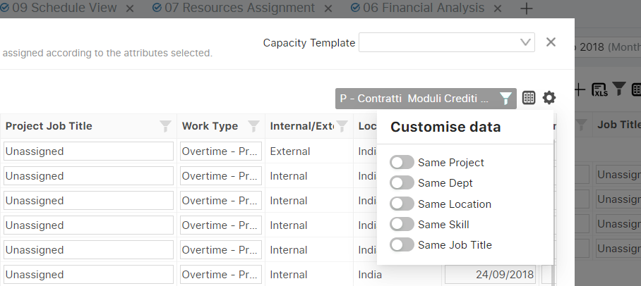

This popup gets open from gantt to assign resources on specific activities.

We have managed the same popup for the resource replacement.

For performance we have provided the user with the ability to choose one out of “Assign %” and “Work”.

By default, “Assign %” is selected.

